MACH4METAL

metalworking machinery
Transito 21
6909 DA BABBERICH Netherlands
Tel. +31 (0)316-247123
Fax: +31 (0)316-247956
info@mach4metal.com
www.mach4metal.com

Bank No : 66.52.13.883
IBAN : NL33 INGB 0665 2138 83
BIC : INGBNL2A

CNC Pressbrake HACO 3100 x 135 T

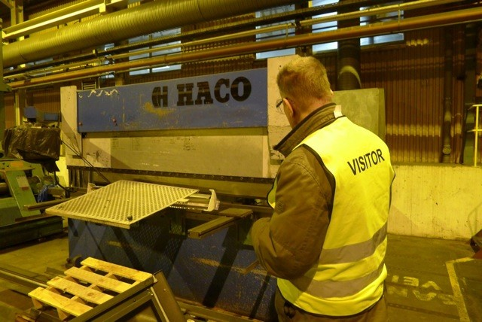
- Make : HACO - Belgium
- Typ : ERM – 30135
- Mach.No : 80156
- Yop : 1992

- Max. bending length : 3.100 mm
- Between housing : 2.600 mm
- Max. force pressure : 135 ton

- Die height : 400 mm
- Stroke : 200 mm
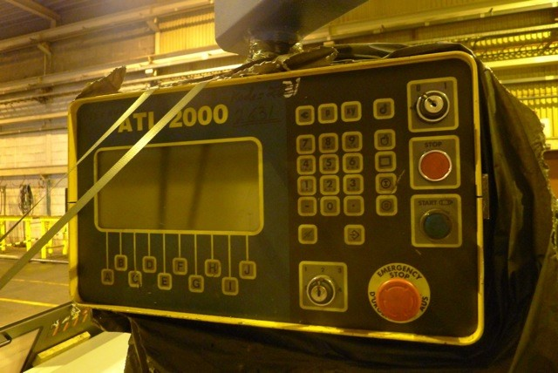
- Throath : 250 mm

- Approching speed : 100 mm/min.
- Working speed : 10 mm/min
- Return speed : 100 mm/min

- CNC Robosoft ATL 2000
controlled are Y¹+Y²+X+ V Crowning

- Dimensions
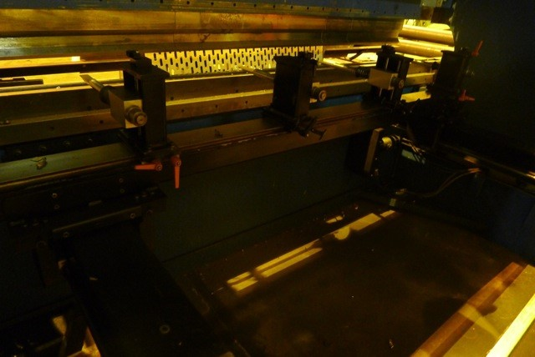
- Length : 3.500
- Width : 1.700
- Height : 2.500
- Weight : 7.800
- Power : 15 kw

- Incl. 1 set tooling

Please Note: The above information has been obtained to the best of our ability and belief from, and from the manufacturers where possible. It is given in good faith, but its accuracy can not be guaranteed. Accordingly, it will not form a representation or constitute contractual terms. We advise you to check any vital details!

